Name ___________________
ACTIVITY 6-6 SH
FINGERPRINT ANALYSIS
Directions: Can you “match” this latent print lifted from the crime scene to any of the suspects’ prints? Using a red pen, identify and circle as many minutiae common to the crime-scene print and the suspect prints to determine which suspect print is most similar to the crime-scene print.

Crime-scene print
All photos © Cengage Learning
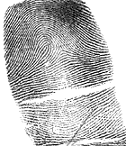
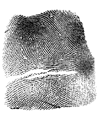  Suspect A | 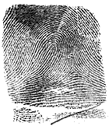  Suspect B | 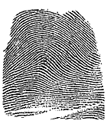  Suspect C
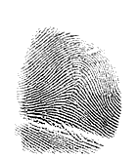  Suspect D  Suspect G  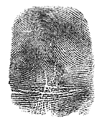 | 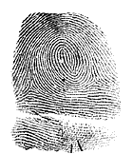  Suspect E |   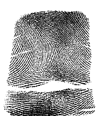  Suspect F  Suspect H

